WEDGE DISPENSER

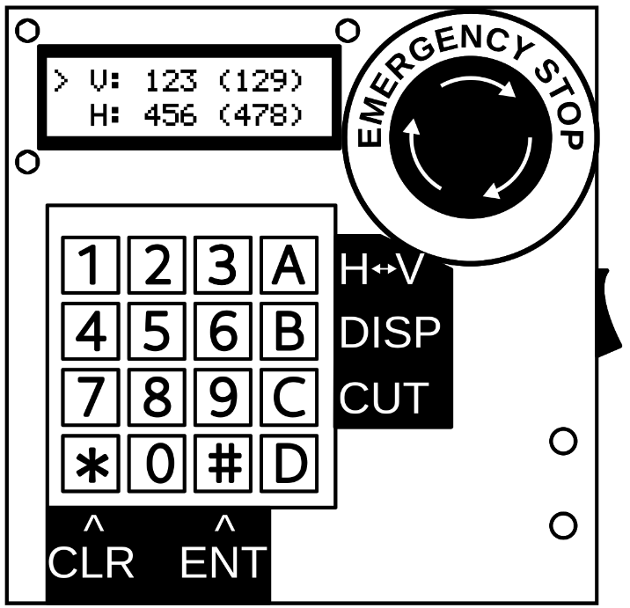
MADE BY WYATT RICHARDS

User Interface
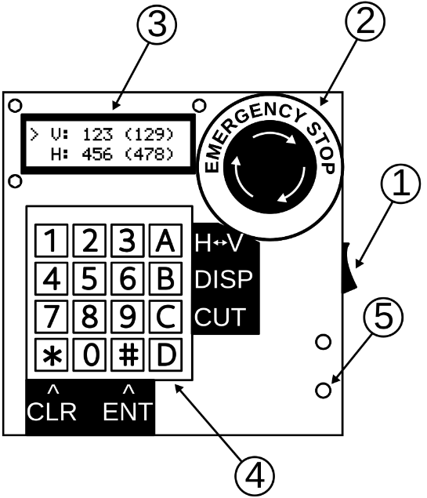
USER INTERFACE KEY
1 | Main power switch
2 | Emergency stop
3 | LCD
4 | Keypad
5 | Power indication light

Operation
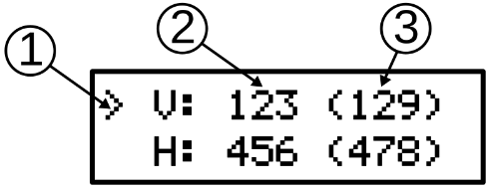
OPERATION KEY
1 | Line indicator
2 | Glass dimension (mm)
3 | Actual dispense dimension (mm)

Operation instructions
- Press “A” on keypad to switch between V (vertical) and H (horizontal) dimension
  - The carat (1) indicates which dimension is currently selected
- Input the glass dimension in millimeters
  - The glass dimension (2) will be displayed with underscores (e.g. __12) to indicate input mode
- Press “#” on keypad to enter dimension
  - 4-digit dimensions will automatically enter when the fourth digit is input
  - The actual glass dimension (3) will automatically update
  - Pressing “*” on keypad will clear all current digits

